**Section 7: Directives Deep Dive**

**Section 7: Lecture 82 //Module Introduction**

1. Let’s repeat quickly what we have learnt this far. We learnt how to build our own directives. We will really dive into the difference between structural and attribute directives and what this star means on structural directives.
2. Attribute vs Structural Directives. Attribute directives are called like this because they sit on elements just like attributes. Structural directives are also same but they basically change the structure of the DOM around this element.
3. If you have ngIf on a paragraph, if this condition is false then this paragraph is removed from the DOM. So, the overall view container is affected.
4. Whereas in the case of attribute directive you never destroy an element from the DOM, you only change properties of that element – for Example the background color. So, we have attribute directives only affecting the element they sit on.
5. Structural directives which affect the whole DOM. The structural directives affect the whole area around the element on which they were placed on. This was the difference between the two types of directives.
6. First we will talk about the directives we know and how to use them. Then we will dive deeper into creating our own directives.

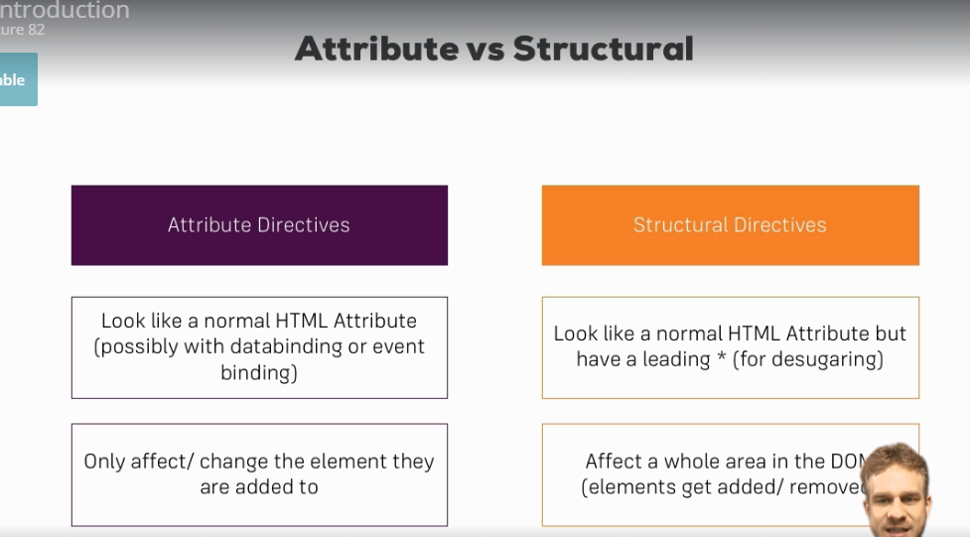

**Section 7: Lecture 83//ngFor and ngIf Recap**